ECE 5200 Exercise 2

Date: 2/18/20, Tuesday, week 5
Due Date: 3/10/20 Tuesday, week 8
Total Points: 50 points

Type the solutions in word document and submit to es-egr-03=>ECE 5200=>Homework & Exam folder => Exercise 2.

Analysis Questions of modulo

- (5%) Compute all powers of 3 (3, 3², 3³, …) modulo 17. Note that 3³ = 27 must be represented as an integer between 0 and 16 or 27 = 10 (mod 17). What is the smallest integer n such that 3^{n} = 1 (mod 17)? What is the smallest k such that 3^{k} = -1 (16) modulo 17? Do all the powers of 3 modulo 17 show all the integers 1, 2, .., through 16 in some different order?
- (5%) Compute all powers of 3 modulo 26. Do all the powers of 3 modulo 26 show all the integers 1 , 2, …, 25 in some order? Now consider all powers of 2 modulo 26. Is any power of that equal to 1 modulo 26? Can you explain why?

- (15%) In page 117 of Stalling’s 6th edition, table 4.7(b) shows how two polynomials in GF (2³) multiply modulo x³ + x + 1. In particular, it shows that when x² multiplies x², the result is x²+ x.

Redo table 4.7(b) using a different irreducible polynomial x³ + x² + 1

- (15%) The textbook shows you GF (p) and GF (2^{n}).

Now let’s do GF(3²).

We need an irreducible polynomial f(x) over GF(3).

- What is the minimum degree of such polynomial?
- Find such a polynomial f(x) (there may be more than one solution)
- With the solution you have from (b), generate the multiplication table similar to table 4.7 (there are 9 entries in GF(3²) in contrast with GF (2³) which has 8 elements.

Tool and running code

- (10%) Download Wireshark from http://ww.wireshark.com and run that.

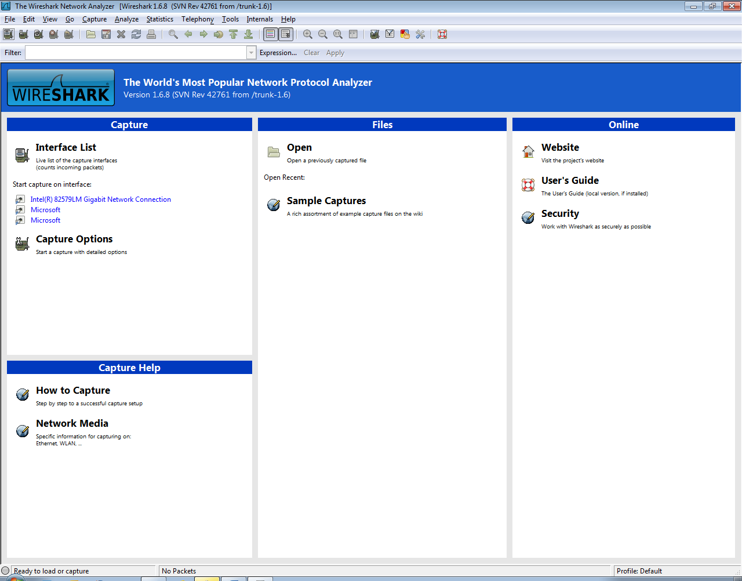

- Start capturing data like below:

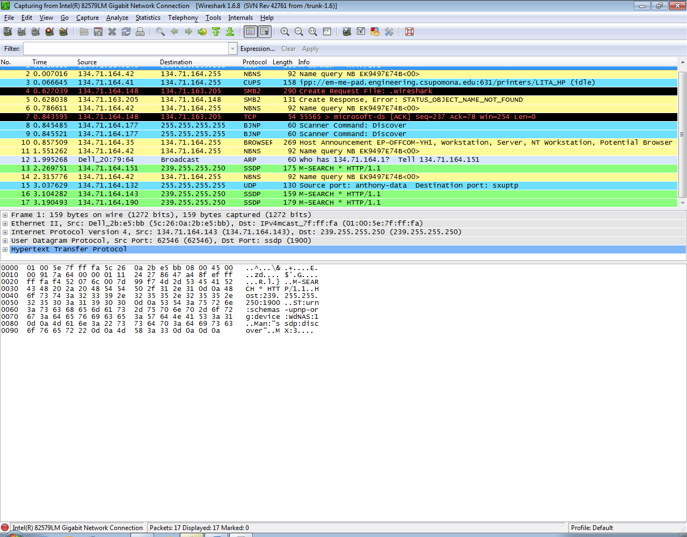
- Do some network activity and see what wireshark captures. Activity could be starting a command window and type ping www.csupomona.edu; could be starting an internet browser etc. Try to find / identify what kind of frames correspond to your network activity.

Extra Credits (43%)

Modulo:

E1. (8%) Analysis: Generalize Q6 and Q7 to powers of a modulo n for any positive integer a and positive integer n (a and n may not be prime numbers or relatively prime). Explain when will the power of a be first equal to 1 modulo n (or maybe that never happens for certain combinations of a and n).

E2. (10%) Programming: Write a (computer) program that inputs a and n and computes and displays powers of a modulo n.

Security:

E3. (15%) Study network sniffer / scanner tools such as Nessus, Nmap and write on what you find (on your computer / network, not what you see on internet, books etc.)
E4 (10%) Study how Wireshark may be used in Intrusion Detection / Prevention etc.

